Abel Junior Matlhare
29303133
IoT Smart Campus Pipeline

Project
ITRI 613

Introduction
Modern stream processing systems are designed to process continuously generated data in real time with minimal latency. Unlike traditional batch processing systems that process data at scheduled intervals, stream processing platforms continuously ingest, analyze, and react to incoming events as they occur. These systems are critical in environments where rapid decision-making is required, such as fraud detection, cybersecurity monitoring, IoT telemetry analysis, and operational analytics.
This project demonstrates the implementation of a real-time IoT Smart Campus Monitoring System using Microsoft Azure cloud services. The system simulates live IoT sensor telemetry from a smart campus environment and processes the data using a scalable streaming architecture. The solution performs real-time analytics, anomaly detection, and visualization through an integrated dashboard.
The implemented solution uses:
- Azure Event Hubs for real-time event ingestion
- Azure Stream Analytics for stream processing
- Azure Cosmos DB for persistent storage
- Microsoft Power BI for dashboard visualization
The system demonstrates modern stream-processing concepts including:
- Event-driven architecture
- Event-time processing
- Windowing
- Aggregation
- Real-time anomaly detection
- Scalable cloud-native streaming pipelines

Project Objectives

Primary Objective
To design and implement a scalable real-time streaming pipeline capable of ingesting, processing, storing, and visualizing IoT telemetry data from a simulated smart campus environment.

Secondary Objectives
- Simulate heterogeneous IoT telemetry streams
- Implement event-time stream processing
- Detect anomalies such as overheating and overcrowding
- Store processed events in a cloud-based NoSQL database
- Build a real-time operational dashboard
- Demonstrate scalability and fault tolerance concepts

System Architecture
The implemented architecture follows an event-driven streaming design.
Python IoT Simulator
↓
Azure Event Hubs
↓
Azure Stream Analytics
↓
Azure Cosmos DB
↓
Power BI Dashboard

Architecture Components

Python IoT Simulator
A custom Python application was developed to simulate smart campus IoT telemetry including:
- Temperature sensors
- Occupancy sensors
- Device status monitoring
The simulator continuously generated JSON-based streaming events.
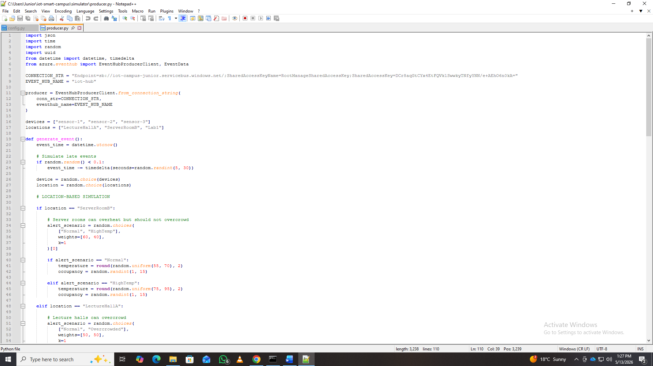
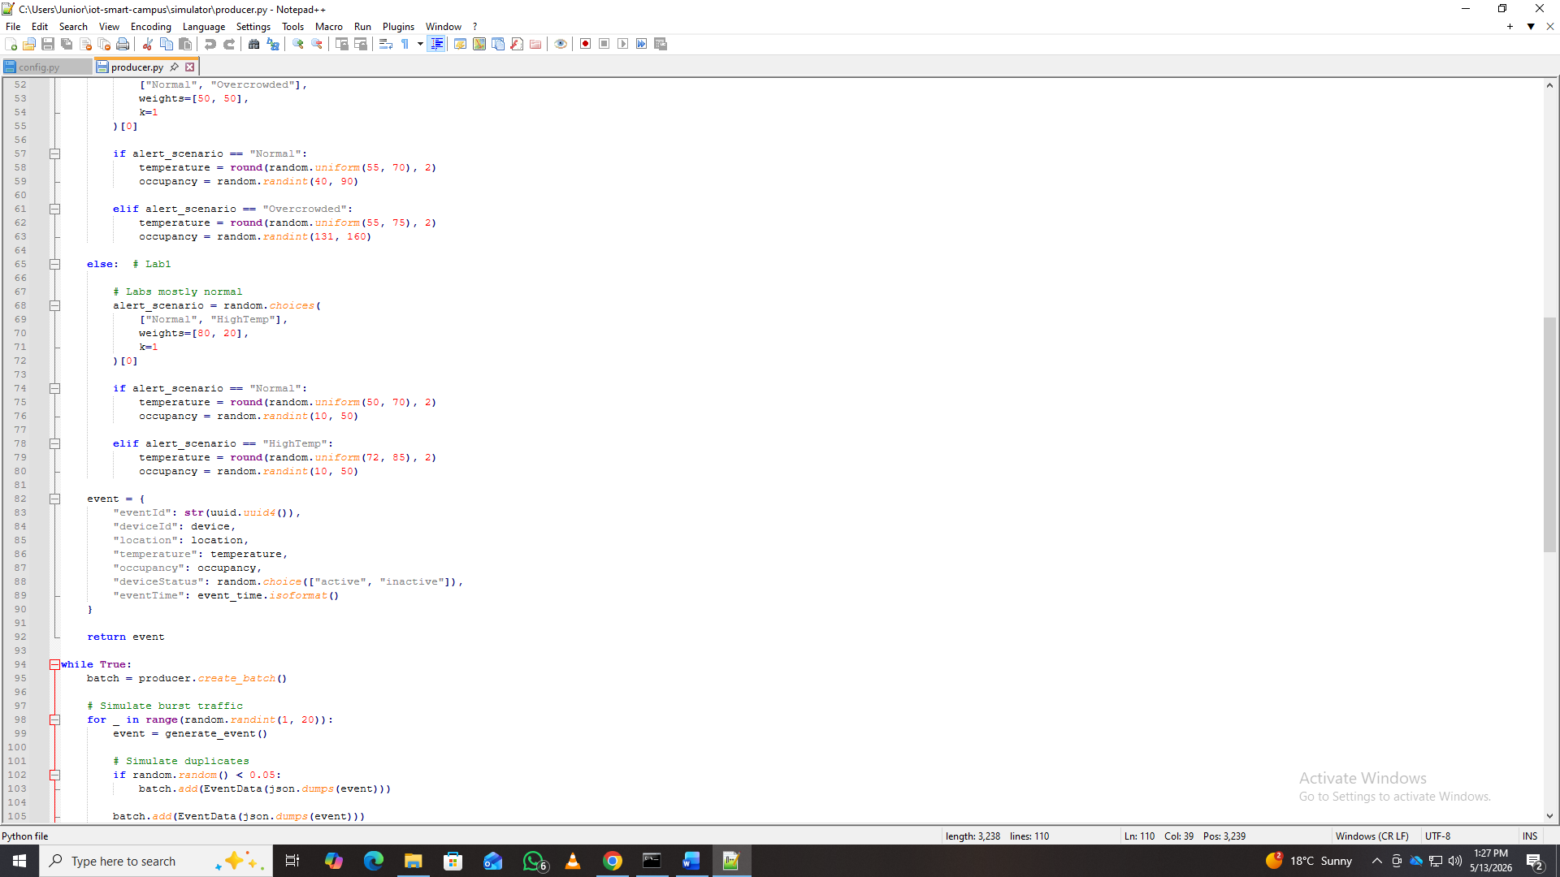
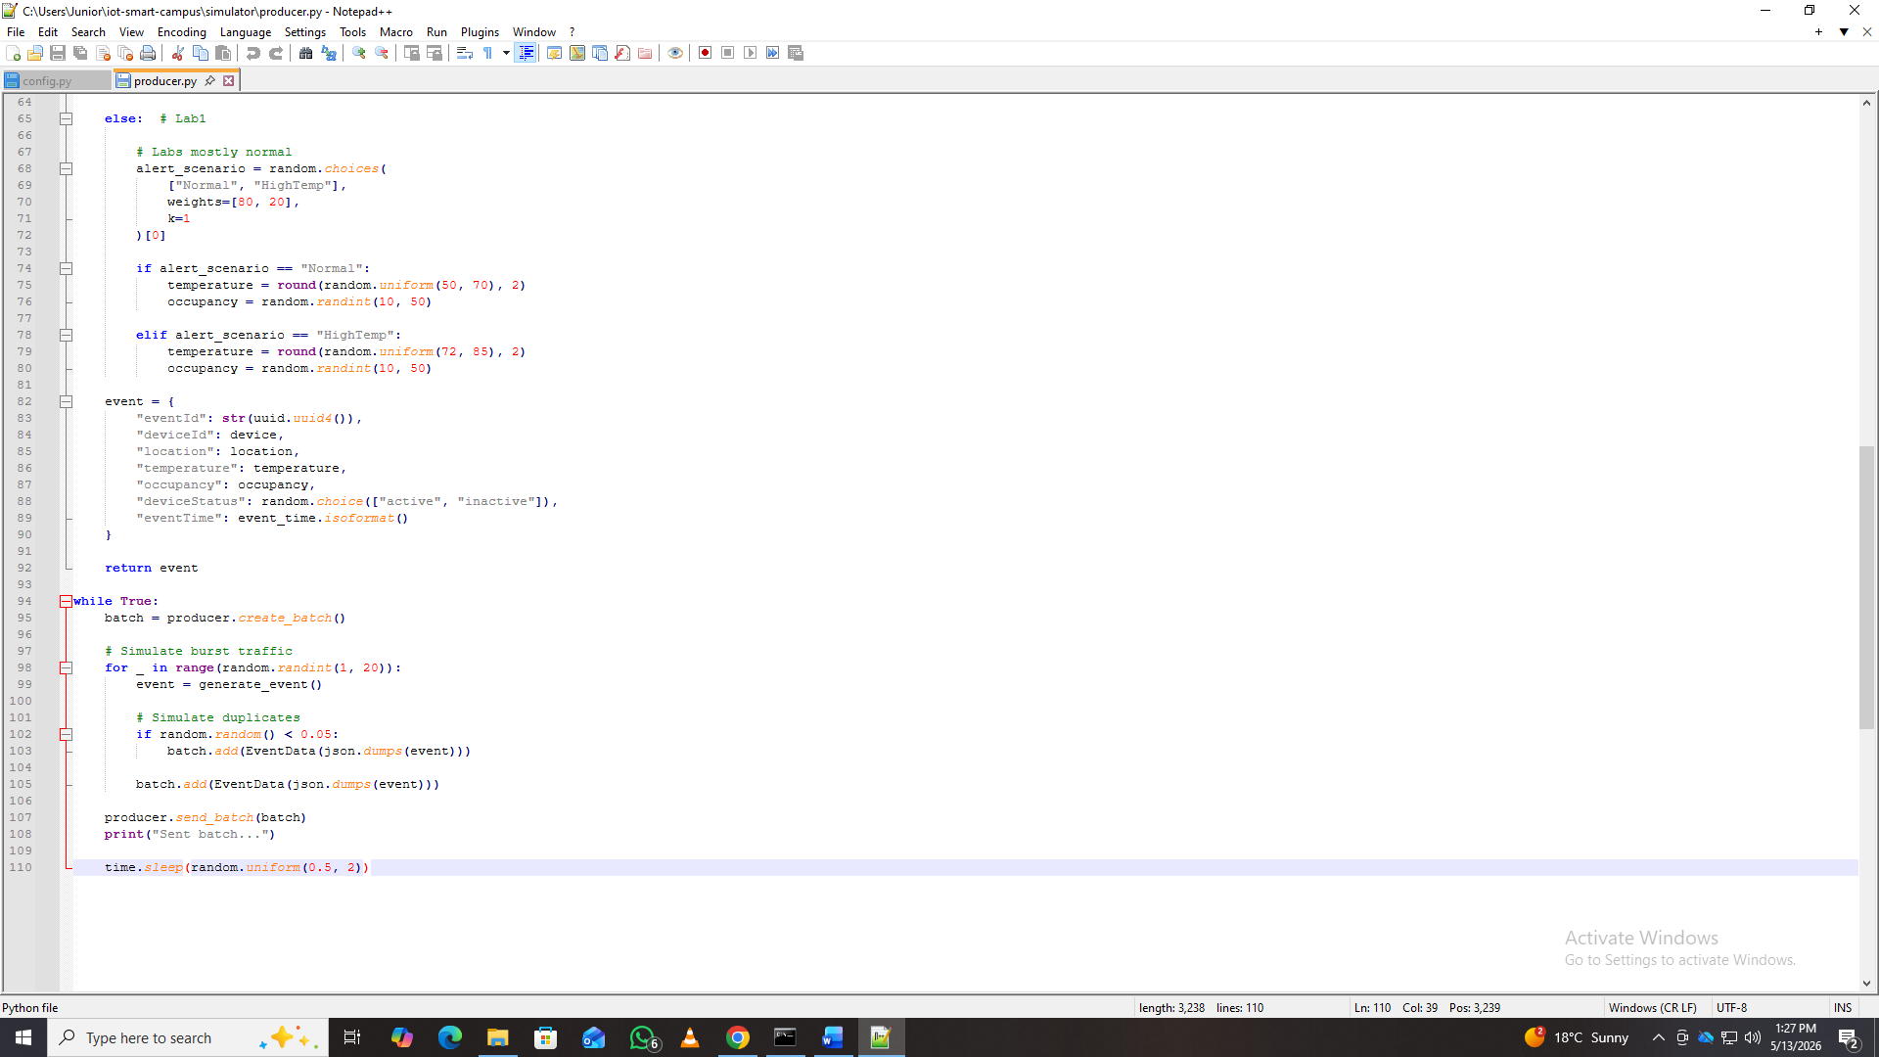
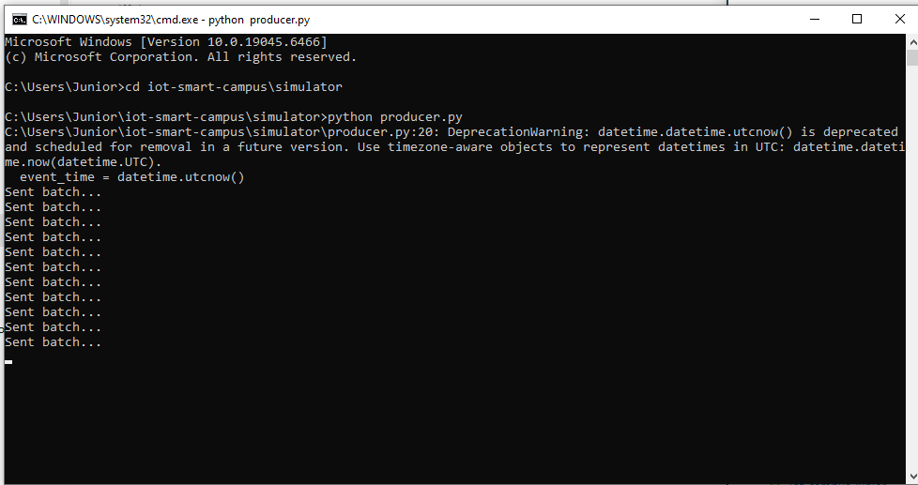

Azure Event Hubs
Azure Event Hubs was used as the scalable event ingestion layer responsible for receiving high-throughput streaming telemetry from simulated devices.
The Event Hub was configured with multiple partitions to support scalability and parallel processing.
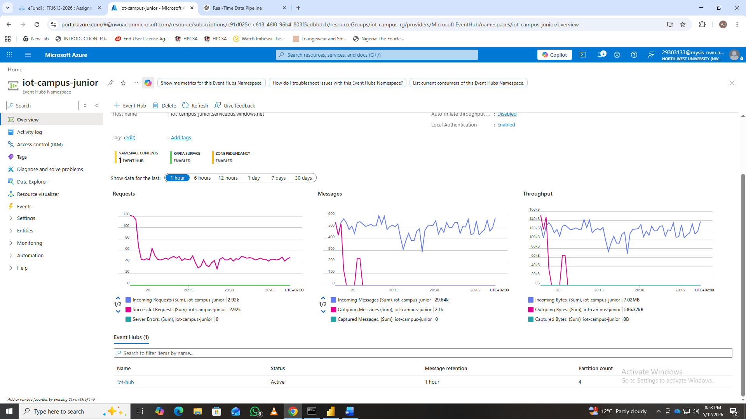
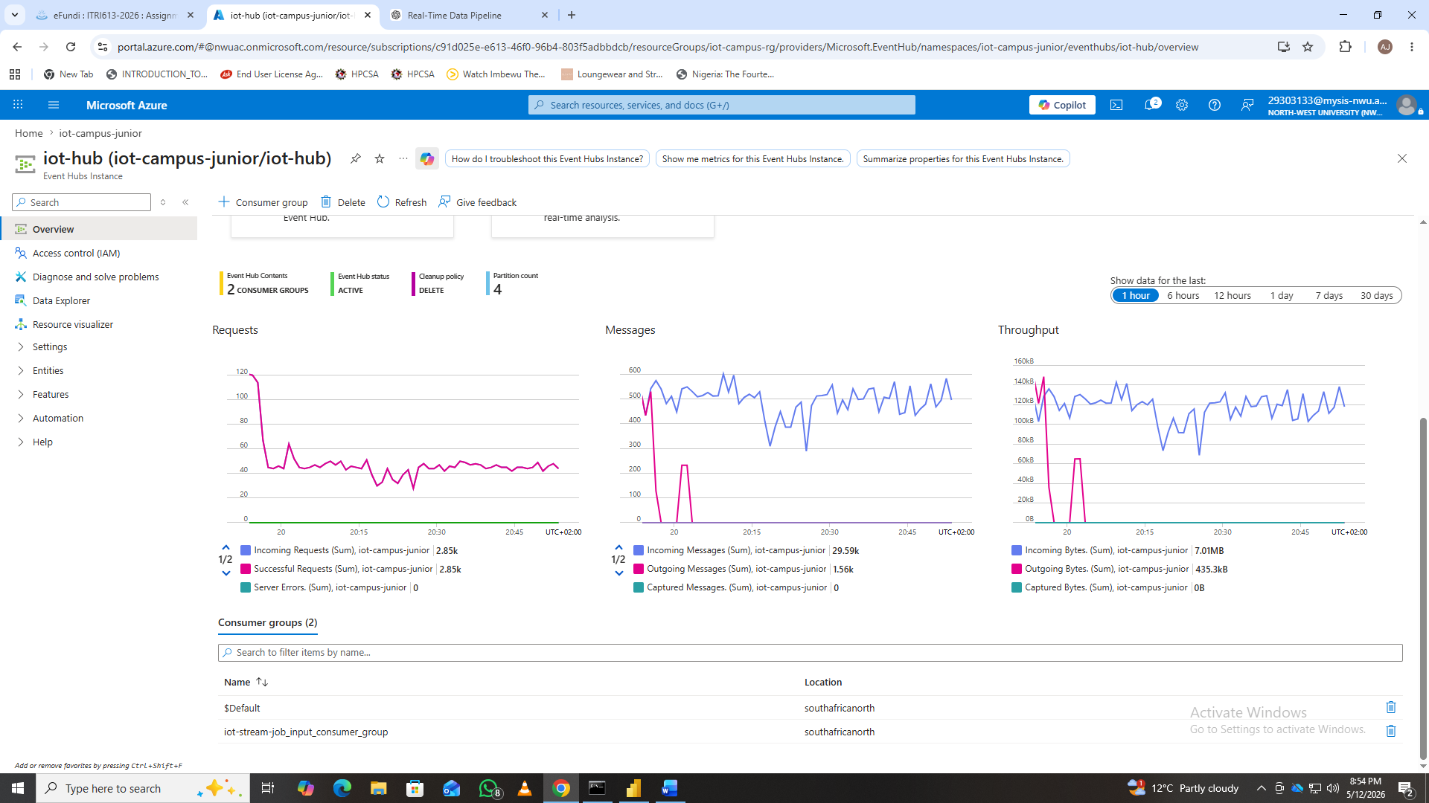

Azure Stream Analytics
Azure Stream Analytics processed incoming telemetry streams in real time.
The service performed:
- Event-time windowing
- Stream aggregation
- Filtering
- Anomaly detection
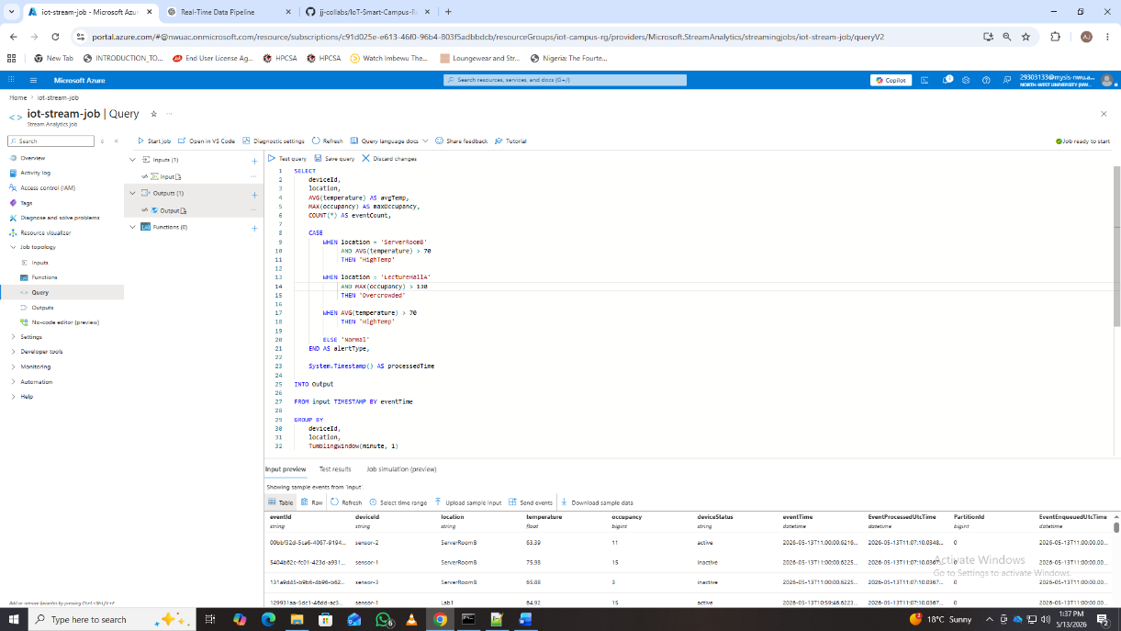
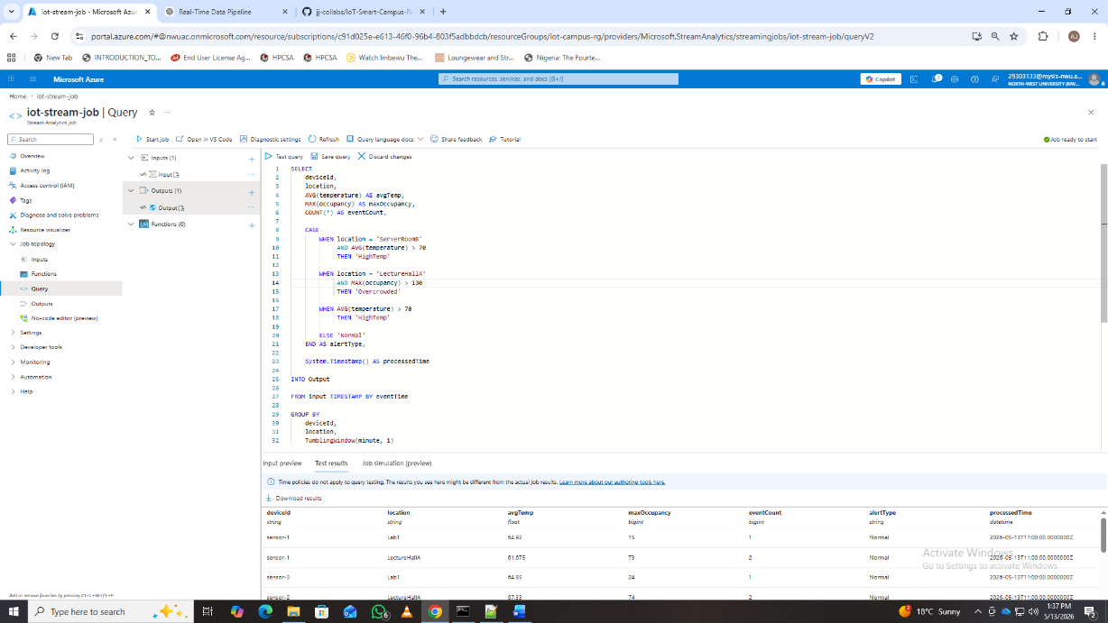
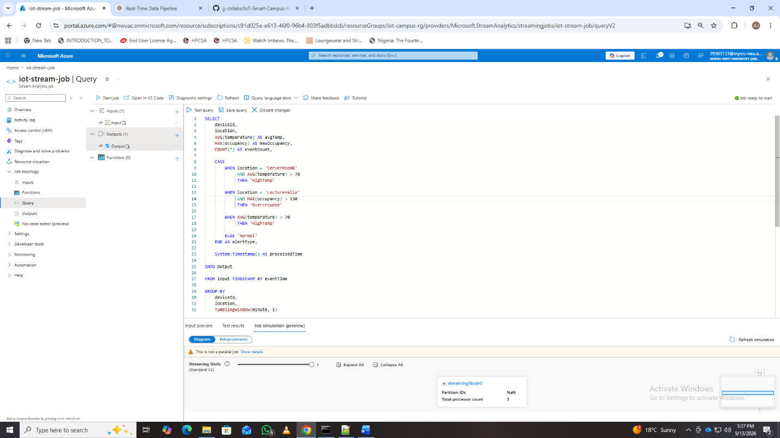

Azure Cosmos DB
Azure Cosmos DB was used to persist processed streaming data as JSON documents.
The database supports:
- Low-latency queries
- Horizontal scaling
- Flexible schema handling

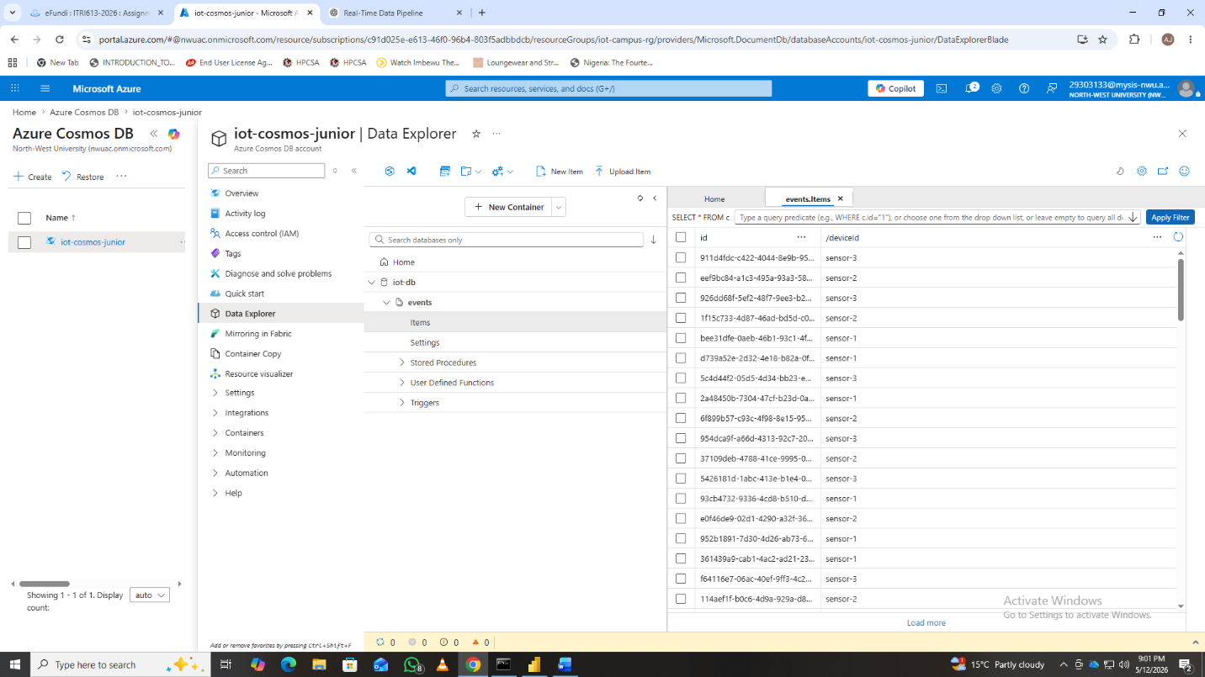

Power BI Dashboard
Microsoft Power BI was used to create a real-time monitoring dashboard for operational analytics and anomaly visualization.
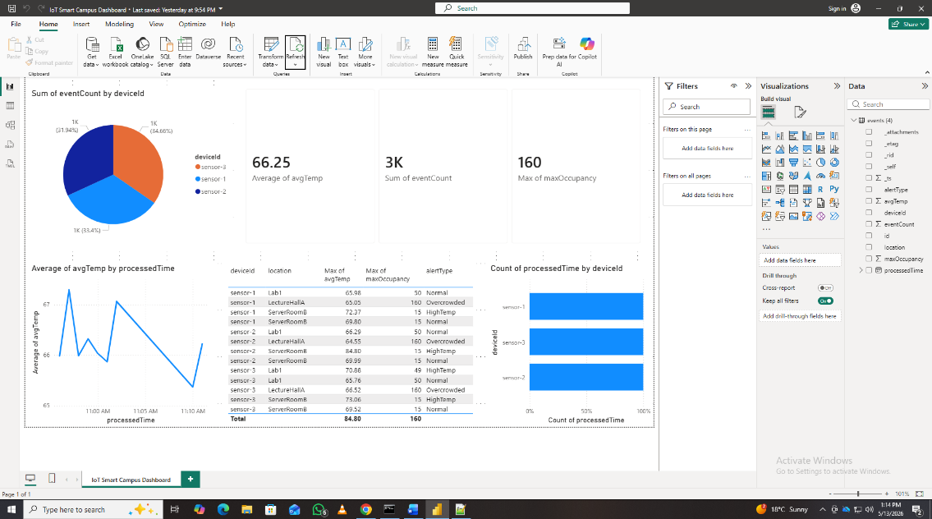

Conclusion
This project successfully demonstrated the implementation of a modern real-time streaming pipeline for IoT smart campus monitoring using Microsoft Azure services.
The solution demonstrated:
- Real-time event ingestion
- Event-time stream processing
- Windowed analytics
- Real-time anomaly detection
- Scalable cloud-native architecture
- Interactive operational visualization

